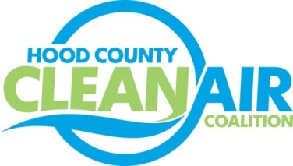
Meeting: Thursday, January 4, 2018
Neely House
304 East Rucker Street, Granbury, Texas 76048
8:30-10:00 a.m.

Agenda

- Call Meeting to Order
- EPA Updates – Randy Pitre, EPA
- Local Updates – Michelle McKenzie
  - Review of December Meeting Summary
  - Report for DFW Clean Cities Annual Meeting
  - Review of Projects
    - Monthly Budget Review for November
    - Status of Projects FY 16/17
  - Ozone Advance Annual Update
  - PACE Presentation Update
  - Loss of Rider 7 Funding
- Regional Updates – Michelle McKenzie
  - EPA Nonattainment Designations
  - Funding Opportunities, www.nctcog.org/aqfunding
  - Volkswagen Settlement Workshop in Austin, Texas, January 17
  - DFW Clean Cities Events
    - Webinar on Idle Reduction Strategies Focusing on Strategies Suitable for Local Government Fleets, January 30, 2018 at 1:30. Details and Registration: www.dfwcleancities.org/webinars
    - Dallas-Fort Worth Clean Cities Annual Survey:
- Other Discussion
- Adjourn

